Polynomial by linked list with template
(Due: PM:9:00, May 30, 2021)

Goal:
This program is designed to demonstrate how to implement a polynomial class based on linked list structure. In this program, linked list and listnode have been upgraded to Chain and Chainnode to compliant with the newest textbook. However, functions and algorithms are unchanged. In the lecture hours, we demonstrated how to add two polynomials, represented by template linked list (Chain). You had to implement polynomial multiplications based on this program.
Linked list is one of the most important programming skills in C++. So you can try to design this program totally by yourself, if possible.

Contents:
- The algorithm to perform polynomial addition has been introduced in lecture notes Linked List I-17.
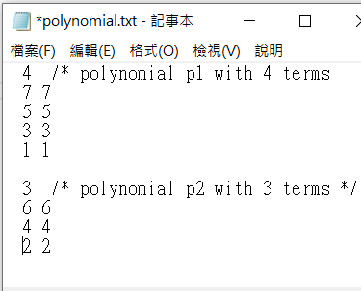
- The main program is shown below. In the provided program, the polynomial addition p3 = p1 + p2 has been designed and you can design the function that can execute p4 = p3 + p1*p2; (In fact, when you finished p1*p2, this instruction can also be executed correctly)

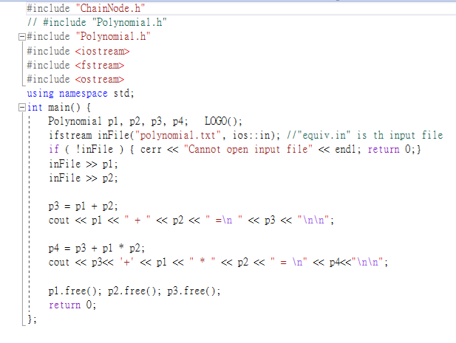
- The correct execution result is shown below. Please check the correctness by hand computing.
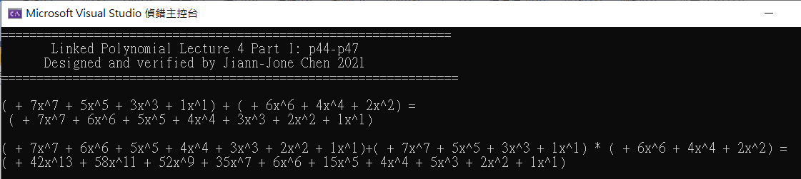
- The execution file polynomial.exe is provided in the directory “./demo” for you to verify your answer.

What to do:

  - All program functions have been introduced in lecture notes, and you can try to design this program by yourself from an empty project. Or you can start programming based on the provided basic program template.
  - Design the function that can perform polynomial multiplication, such that the instruction p4 = p3 + p1*p2 can execute correctly.

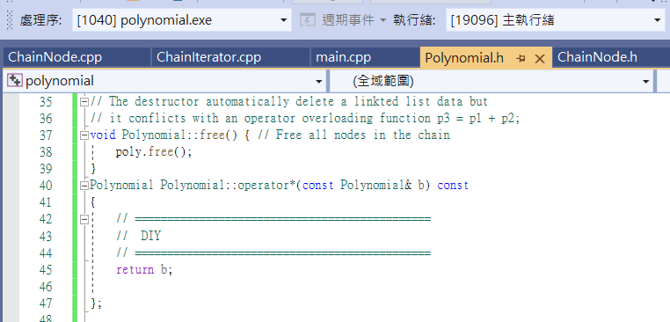

  - You had to release (delete) allocated memory when building the polynomial. The following program shown below is reserved for you to implement. Can we perform this function by destructor of Polynomial class? If possible, please discuss this question in your report.
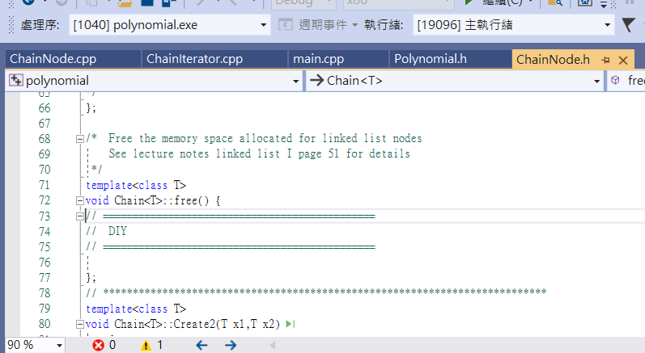
- The standard platform is Visual Studio 2019. Please don’t use other ones for the sake of correct compiling and execution.
- Write a short report to describe what you have done and what problems you solved in this program homework. I will ask you about this program design in the final exam.
- Be sure the modify the LOGO to show your student ID on the screen.
- I will check the correctness of your program by setting different polynomial inputs specified by the polynomial.txt file.

